**CONTENTS**

|  |  |  |
| --- | --- | --- |
| **Topic No** | **Topic** | **Page No** |
| 1 | **1. INTRODUCTION** |  |
| 1.1 | 1.1 Background | 2-3 |
| 1.2 | 1.2 Objectives | 4-6 |
| 1.3 | 1.3 Purpose, Scope, and Applicability | 7-14 |
| 1.3.1 | 1.3.1 Purpose | 7-8 |
| 1.3.2 | 1.3.2 Scope | 9-11 |
| 1.3.3 | 1.3.3 Applicability | 12-14 |
| 2 | **2. SURVEY OF TECHNOLOGIES** |  |
| 3 | **3. REQUIREMENTS AND ANALYSIS** |  |
| 3.1 | 3.1 Problem Definition | 15-17 |
| 3.2 | 3.2 Requirements Specification | 18-20 |
| 3.3 | 3.3 Planning and Scheduling | 21-24 |
| 3.4 | 3.4 Software and Hardware Requirements | 25-27 |
| 3.5 | 3.5 Preliminary Product Description | 28-29 |
| 3.6 | 3.6 Conceptual Models | 30-31 |
| 4 | **4. SYSTEM DESIGN** |  |
| 4.1 | 4.1 Basic Modules | 32-34 |
| 4.2 | 4.2 User Interface design | 35-36 |
| 4.3 | 4.3 Security Issues | 37-40 |

**INTRODUCTION**

Started with the vision to provide indigenous and eco friendly products to the community at large, all the while aiming to preserve the natural resources of our country, SavvyShopper has evolved as the face of unmatched.

Herbal and Ayurvedic products. SavvyShopper came into being with a mere range of 18 products which slowly multiplied into health and nutrition, agriculture and veterinary, skin care, personal care, home care, baby care, and food products. Garments and books also added in the diverse portfolio of SavvyShopper.

Our extensive range of herbal products include the best haldi drops for immunity in addition to the best tulsi drops for cold.

Our women wellbeing section consists of herbal medicines for women health as well as cotton sanitary napkins for worriless days.

You can also buy aloe vera juice and other syrups to control sugar along with other Ayurvedic medicines that are meant to treat diabetes.

We have my riad of products in our skincare section as well, including the best facewash for acne skin or oily skin type.

The organic harvesting products are also a hit along with various other products.

**OBJECTIVES**

SavvyShopper website serves as a central hub for a company's marketing efforts. Its objectives typically align with the broader goals of the SAVVYSHOPPER strategy.

Here are some common objectives:

**1. Brand Awareness and Recognition:**

Increasing brand visibility: Enhancing the company's brand visibility and recognition among the target audience.

Consistent messaging: Ensuring consistent messaging across all marketing channels to reinforce the brand identity.

**2. Conversion:**

Providing valuable content: Offer valuable content, such as blog posts, whitepapers, or case studies, to attract and engage potential customers.

Optimizing for conversions: Design the website with clear calls to action and optimize for conversions (e.g., sign-ups, downloads, purchases).

**3. Customer Engagement and Retention:**

Building customer relationships: Fostering strong relationships with existing customers through personalized content and communication.

Providing excellent customer service: Offering exceptional customer service through the website, such as contact forms.

Encouraging customer loyalty: Implement loyalty programs or reward systems to incentivize repeat business.

**4. Public Relations and Reputation Management:**

Managing public perception: Shaping public perception of the brand through templates.

Addressing customer concerns: Responding promptly to customer inquiries and address any negative feedback to maintain a positive reputation.

**5. Data-Driven Marketing:**

Tracking and analyzing performance: Using analytics tools to track website performance, measure key metrics, and identify areas for improvement.

Making data-driven decisions: Using data insights to inform marketing strategies and optimize campaigns for better results.

**6. Sales Support:**

Provide product information: Offering detailed product information and specifications to assist potential customers in making informed decisions.

Facilitate sales inquiries: Providing easy ways for customers to contact the sales team or request a quote.

By effectively addressing these objectives, SavvyShopper can play a crucial role in achieving a company's overall marketing goals and driving business success.

**PURPOSE**

Here's a suggested purpose for a website similar to SAVVYSHOPPER:

To provide a comprehensive online platform that empowers businesses to develop effective (SAVVYSHOPPER) strategies, optimize their marketing efforts, and achieve measurable results in today's competitive landscape.

This purpose statement captures the essence of an SavvyShopper by emphasizing the following key points:

* Comprehensive Platform: The website offers a wide range of resources and tools to support businesses.
* Effective Strategies: It should help businesses develop and implement effective SAVVYSHOPPER strategies that align with their goals.
* Optimization: Website provides guidance on optimizing marketing efforts to maximize ROI.
* Measurable Results: It focuses on helping businesses achieve tangible and measurable outcomes from their marketing initiatives.

By clearly defining our website's purpose, we can ensure that it aligns with our goals and provides value to our users.

**SCOPE**

SAVVYSHOPPER website typically encompasses a broad range of features and functionalities to support businesses in their marketing efforts. Here's a general outline of the scope:

**Core Features:**

* Brand Showcase: A clear and compelling presentation of the company's brand identity, values, and mission.
* Product/Service Information: Detailed information about the products or services offered, including features, benefits, and pricing.
* Content Marketing: A blog or news section with informative and engaging content to attract and engage visitors.
* Contact Information: Easy-to-find contact information, including phone numbers, email addresses, and a contact form.

**Additional Features (Depending on Specific Needs):**

* E-commerce: If the company sells products online, an integrated e-commerce platform.
* Customer Support: A dedicated section for customer support, including FAQs, contact forms, or live chat.
* Lead Generation Forms: Forms to capture visitor information for lead generation and follow-up.
* Marketing Automation: Integration with marketing automation tools to streamline email marketing and lead nurturing.
* CRM Integration: Integration with a customer relationship management (CRM) system to manage customer data and interactions.
* Customizable Templates: Customizable templates for different pages and layouts to match the company's branding.

**Specific Features for SAVVYSHOPPER:**

1. Case Studies: Showcase successful SAVVYSHOPPER campaigns and their results.
2. Client Testimonials: Testimonials from satisfied clients highlighting the benefits of SAVVYSHOPPER services.
3. SAVVYSHOPPER Services Overview: A detailed overview of the SAVVYSHOPPER services offered, including advertising, public relations, social media marketing, etc.
4. Industry Insights: Articles or blog posts on industry trends and best practices related to SAVVYSHOPPER.

The specific scope of an SavvyShopper may vary depending on the company's size, industry, and marketing goals. However, by incorporating these core features and considering the additional features, a website can effectively support an SAVVYSHOPPER strategy and achieve its objectives.

**APPLICABILITY**

An SAVVYSHOPPER (Integrated Marketing Communications) website has broad applicability across various industries and organizations. It can be a valuable tool for businesses of all sizes, from startups to large corporations.

Here are some key areas where an SavvyShopper website can be applied:

**1. B2B (Business-to-Business) Companies:**

* Lead Generation: Attract potential clients and generate leads through targeted content and lead generation forms.
* Brand Awareness: Establish the company as a thought leader in the industry through informative blog posts and industry news.
* Customer Relationship Management: Build and maintain relationships with clients through personalized content and communication.

**2. B2C (Business-to-Consumer) Companies:**

* E-commerce: Sell products or services directly to consumers online.
* Brand Building: Create a strong brand identity and engage with customers through social media and content marketing.
* Customer Support: Provide excellent customer service through online resources and support channels.

**3. Non-Profit Organizations:**

* Fundraising: Raise funds for the organization through donations and online campaigns.
* Advocacy: Promote awareness of the organization's mission and cause.
* Community Engagement: Connect with the community and build relationships.

**4. Government Agencies:**

* Public Information: Provide information about government services and programs.
* Citizen Engagement: Facilitate communication and feedback from citizens.
* Transparency: Promote transparency and accountability.

**5. Professional Services:**

* Showcase Expertise: Highlight the company's expertise and qualifications.
* Generate Leads: Attract potential clients through case studies and testimonials.

In summary, an SavvyShopper can be a valuable asset for businesses and organizations across a wide range of industries. By effectively utilizing the capabilities of an SavvyShopper, companies can achieve their marketing goals, build brand awareness, generate leads, engage customers, and drive business growth.

**SURVEY OF TECHNOLOGIES**

MySQL: A Popular Relational Database Management System

MySQL is a widely used open-source relational database management system (RDBMS) that is known for its speed, reliability, and ease of use. It is a popular choice for a variety of applications, including web development, data warehousing, and e-commerce.

Key Features:

* Relational Database: Stores data in tables, where each table represents a collection of related data.
* SQL Support: Uses the Structured Query Language (SQL) to interact with the database, allowing you to create, modify, and query data.
* High Performance: Optimized for speed and efficiency, making it suitable for handling large datasets and heavy workloads.
* Scalability: Can be scaled to handle growing data volumes and user demands.
* Reliability: Offers robust features to ensure data integrity and consistency.
* Flexibility: Supports various data types and storage engines, providing flexibility in database design.
* Community Support: A large and active community of developers contributes to MySQL's development and provides support.
* Integration: Easily integrates with popular programming languages and frameworks.
* Security: Offers features like user authentication, access control, and encryption to protect data.
* Cost-Effective: Free and open-source, making it a cost-effective solution for many applications.
* Common Use Cases:
* Web Applications: Storing and retrieving data for websites and web applications.
* E-commerce: Managing product catalogs, customer information, and order data.
* Data Warehousing: Storing and analyzing large datasets for reporting and analytics.
* Content Management Systems: Powering content-driven websites and applications.
* Scientific Research: Storing and analyzing scientific data.
* MySQL is a versatile and powerful database management system that has become a standard choice for many developers and organizations. Its combination of performance, reliability, and ease of use makes it a popular option for a wide range of applications.
* https://github.com/arunsharma12345/portfolio PHP: A Versatile Server-Side Scripting Language
* PHP is a widely used general-purpose scripting language that is primarily designed for web development. It is known for its simplicity, flexibility, and efficiency, making it a popular choice for building dynamic websites and web applications.
* Key Features:
* Server-Side Scripting: Executes on the server, generating HTML content that is sent to the client's browser.
* Cross-Platform Compatibility: Runs on various operating systems, including Windows, macOS, and Linux.
* Easy to Learn: Has a relatively simple syntax, making it accessible to beginners and experienced developers alike.
* Object-Oriented Programming: Supports object-oriented programming principles for better code organization and reusability.
* Large Community: A vast and active community of developers provides support, resources, and contributions.
* Extensive Functionality: Offers a rich set of built-in functions for tasks like string manipulation, file handling, and database interaction.
* Framework Support: Compatible with popular PHP frameworks like Laravel, Symfony, and CodeIgniter, which provide a structured approach to web development.
* Database Integration: Seamlessly integrates with various databases, including MySQL, PostgreSQL, and SQLite.
* Security: Offers features to help protect against common security vulnerabilities, such as SQL injection and cross-site scripting.
* Performance: Continuously improving performance, making it suitable for high-traffic websites and applications.
* Common Use Cases:
* Dynamic Websites: Creating websites with interactive elements, such as user logins, forms, and personalized content.
* Web Applications: Building complex web applications, including e-commerce platforms, content management systems, and social networking sites.
* API Development: Developing RESTful APIs for data exchange between different applications.
* Command-Line Scripts: Creating scripts to automate tasks and perform system administration.
* Embedded Systems: Integrating PHP into embedded devices for web-based control and monitoring.

PHP's versatility and ease of use have made it a cornerstone of web development for many years. Its ability to handle a wide range of tasks, from simple scripts to complex applications, has solidified its position as a popular choice for developers worldwide.

**PROBLEM DEFINITION**

**Understanding the Core Problems:**

An SAVVYSHOPPER (Integrated Marketing Communications) website often aims to solve specific problems faced by businesses or individuals seeking marketing services.

Here are some common problem areas that an SavvyShopper can address:

1. Lack of Clarity and Consistency:

* Conflicting Messages: Businesses may struggle to maintain consistent messaging across different marketing channels, leading to confusion among target audiences.
* Ineffective Coordination: A lack of coordination between various marketing teams can hinder the overall effectiveness of marketing efforts.

2. Limited Reach and Engagement:

* Narrow Audience: Businesses may be unable to reach their target audience effectively due to limited marketing channels or ineffective messaging.
* Low Engagement: Marketing campaigns may fail to capture the attention of the target audience and generate meaningful interactions.

3. Inefficient Resource Allocation:

* Wasted Budget: Businesses may allocate resources to marketing activities that do not deliver a positive ROI.
* Missed Opportunities: Valuable marketing opportunities may be overlooked due to a lack of data-driven insights.

4. Measurement and Tracking Challenges:

* Lack of Data: Businesses may struggle to track the effectiveness of their marketing campaigns and measure ROI.
* Ineffective Analysis: Data may not be analyzed effectively to identify areas for improvement.

5. Staying Ahead of Trends:

* Outdated Strategies: Businesses may rely on outdated marketing strategies that are no longer effective in today's digital landscape.
* Rapid Changes: The marketing landscape is constantly evolving, making it difficult for businesses to keep up with the latest trends and technologies.

**Addressing These Problems:**

An SavvyShopper can help businesses address these problems by providing:

* **Comprehensive SAVVYSHOPPER Strategies-**

Tailored marketing plans that integrate various channels to deliver consistent messaging.

* **Data-Driven Insights-**

Tools and techniques to measure campaign effectiveness and optimize resource allocation.

* **Expertise and Guidance-**

Access to experienced professionals who can provide valuable advice and support.

* **Stay Updated-**

Information on the latest marketing trends and technologies to ensure that businesses remain competitive.

By effectively addressing these common problems, SavvyShopper website can help businesses achieve their marketing goals and improve their overall success.

**REQUIREMENTS SPECIFICATION**

**Core Requirements:**

An SAVVYSHOPPER website should be designed to meet specific requirements that align with the goals of the business and its target audience.

Here's a breakdown of the key requirements:

**Functional Requirements:**

* Brand Identity Integration: The website should accurately reflect the company's brand identity, including its logo, colours, and messaging.
* Content Management System (CMS): A user-friendly CMS should be implemented to allow for easy content updates and management.

**Mobile Responsiveness:**

* The website should be fully responsive to ensure optimal viewing on various devices, including smartphones and tablets.
* E-commerce Functionality: If applicable, the website should include e-commerce features for selling products or services online.
* Lead Generation Forms: Forms should be implemented to capture visitor information and generate leads.
* Analytics Integration: Integration with analytics tools to track website performance, measure key metrics, and analyze user behavior.
* Social Media Integration: Integration with social media platforms to facilitate interaction and community building.

**Non-Functional Requirements:**

* Performance: The website should load quickly and have a smooth user experience.
* Security: Robust security measures should be in place to protect user data and prevent unauthorized access.
* Accessibility: The website should comply with accessibility standards (e.g., WCAG) to ensure it can be used by people with disabilities.
* Scalability: The website should be designed to handle future growth and increased traffic.
* Maintainability: The codebase should be well-structured and easy to maintain and update.

**Specific Requirements for SAVVYSHOPPER:**

* Case Study Showcase: A dedicated section to showcase successful SAVVYSHOPPER campaigns and their results.
* Services Overview: A clear and concise overview of the SAVVYSHOPPER services offered.
* Industry Insights: Regular updates on industry trends and best practices.

**Additional Considerations:**

* Target Audience: The website should be designed to appeal to the specific needs and preferences of the target audience.
* Budget: The project budget will influence the scope and complexity of the website.
* Timeline: The desired timeline for development and launch will need to be considered.

**PLANNING AND SCHEDULING**

Effective planning and scheduling are crucial for the successful development and launch of an SAVVYSHOPPER website.

Here's a breakdown of the key steps involved:

1. Project Planning:

* Define Scope: Website goals, features and functionality included in the website.
* Identify Stakeholders: Identify all stakeholders involved in the project, including development team and any other relevant parties.
* Create Project Charter: Development of the project's objectives, scope, deliverable and timelines will be included.

2. Project Timeline:

* Break Down Tasks: Breaking down the project into smaller, manageable tasks.
* Estimate Duration: Estimating the time required to complete each task.
* Create Gantt Chart: Gantt chart or project management tool to visualize the project timeline will be included.

3. Resource Allocation:

* Identify Resources: Identifying the resources needed for the project, including personnel, equipment, and software.
* Allocate Resources: Allocating resources to each task based on their requirements and availability.

4. Risk Management:

* Identify Risks: Identifying potential risks that could impact the project, such as delays, budget overruns, or technical issues.
* Develop Mitigation Strategies: Develop strategies to mitigate or address these risks.

5. Communication Plan:

* Define Communication Channels: Establish clear communication channels between stakeholders.
* Set Communication Frequency: Determine the frequency of communication and the types of information to be shared.

6. Quality Assurance:

* Define Quality Standards: Quality standards and criteria of the website is defined.
* Conduct Testing: Testing throughout the development process to ensure quality and identify defects.

7. Launch and Maintenance:

* Launch Plan: Develop a launch plan outlining the steps involved in launching the website.
* Post-Launch Evaluation: Evaluating the website's performance after launch and making necessary adjustments.
* Ongoing Maintenance: Establishing a plan for ongoing maintenance, including updates, security patches, and performance optimization.

**Key Considerations for SavvyShoppers:**

Alignment with Strategy: Ensure that the website's planning and scheduling align with the overall strategy.

User Experience (UX): Prioritizing UX design to create a user-friendly and engaging website.

Marketing Integration: Ensuring that the website is integrated with other marketing channels.

By following these steps and considering the specific requirements of a SavvyShopper website , we can effectively plan and schedule the development process to ensure a successful launch and ongoing success.

**SOFTWARE AND HARDWARE REQUIREMENTS**

**Software Requirements:**

Web Development Tools:

* Code Editor: Visual Studio Code.
* Version Control: Git
* Web Server: Apache, Nginx, or IIS.
* Database Management System (DBMS): MySQL or MongoDB.
* Programming Languages: HTML, CSS, JavaScript, and a server-side language like PHP.
* Content Management System (CMS): A CMS like WordPress can simplify content management and website administration.
* Integrated Development Environment (IDE): A comprehensive IDE like PyCharm can enhance development efficiency.

Design Tools:

* Graphic Design Software: Adobe Photoshop or Figma for creating visuals and designs.
* Wireframing Tools: Figma or Sketch for creating wireframes and prototypes.

**Hardware Requirements:**

The hardware requirements for an SavvyShopper will depend on the expected traffic, data storage needs, and the complexity of the website.

However, a typical setup might include:

* Server: A dedicated server or cloud-based hosting solution.
* Storage: Sufficient storage capacity for website files, databases, and backups.
* Network Connectivity: Reliable internet connectivity.

Additional Considerations:

* Scalability: Ensure the website can handle future growth and increased traffic.
* Mobile Optimization: Optimize the website for mobile devices to provide a seamless user experience.

**PRODUCT DESCRIPTION**

**Preliminary Product description:**

Baby care:

Baby skin is more delicate and sensitive than adult skin. Baby care products are formulated with mild and gentle ingredients to avoid irritation and allergies. Harsh chemicals or fragrances in regular products for adults can be too harsh for a baby's skin.

Health care:

Products are Organic without any traces of animal fat, superior quality and have International Standards that will boost your overall health and keep diseases at bay.

Food care:

It is beneficial for asthma, cough. It is also useful for sleep disorders, cancer, hardening of the arteries, intestinal gas, depression, menstrual discomfort, heartburn and dry skin.

**CONCEPTUAL MODEL**

In our SavvyShopper website, various conceptual models help guide strategy and implementation. These models ensure that all marketing channels and messages are consistent and reinforce the brand's positioning.

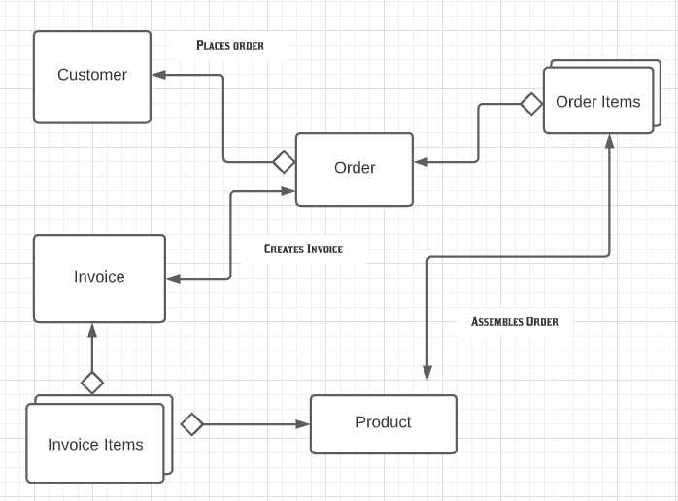

**Fig.3.6.1. Conceptual Diagram**

**BASIC MODULE**

The SavvyShopper is a complex platform with numerous modules, each serving a specific purpose. Here are some of the basic modules that you might encounter:

1. Homepage:

* Welcome message: A greeting to visitors, often accompanied by a tagline or slogan.
* Featured content: Highlights of recent news, events, or resources.
* Search bar: Allows visitors to quickly find information.
* Navigation menu: Provides links to different sections of the website.

2. About Us:

* Mission and vision: Statements outlining the organization's goals.
* History: A brief overview of the SAVVYSHOPPER's founding and development.
* Leadership: Information about the SAVVYSHOPPER's key personnel.
* Board of directors: Details about the members of the governing body.

3. Programs:

* Overview: A general description of the SAVVYSHOPPER's programs.
* Program listings: Detailed information about each program, including objectives, eligibility criteria, and application process.
* Testimonials: Quotes from satisfied participants or beneficiaries.

4. Events:

* Calendar: A list of upcoming events with dates, times, and locations.
* Event details: Descriptions of individual events, including speakers, topics, and registration information.
* Photo galleries: Collections of images from past events.

5. News:

* Press releases: Official announcements from the SAVVYSHOPPER.
* News articles: Coverage of relevant news stories.
* Media library: A repository of multimedia content, such as videos and podcasts.

6. Resources:

* Publications: Books, articles, and reports.
* Research: Findings from SAVVYSHOPPER studies.
* Tools: Online resources for members or the public.

7. Membership:

* Benefits: Advantages of joining the SAVVYSHOPPER.
* Membership levels: Different categories of membership with varying privileges.
* Application process: Instructions for becoming a member.

8. Contact Us:

* Contact information: Addresses, phone numbers, and email addresses.
* Contact form: A web form for visitors to submit inquiries.

9. Donate:

* Donation options: Different ways to contribute to the SAVVYSHOPPER.
* Tax information: Details about tax-deductible donations.

10. Footer:

* Social media links: Connections to the SAVVYSHOPPER's social media profiles.
* Sitemap: A comprehensive list of all website pages.
* Copyright information: Legal notices and terms of use.

**USER INTERFACE DESIGN**

**Basic structure:**

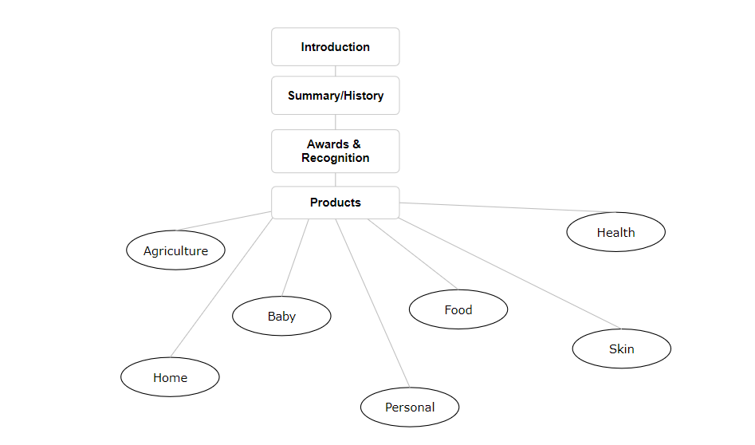

**SECURITY ISSUES**

**Security Issues in Website Development**

**Input Validation and Sanitization**

* Injection Attacks: SQL, XSS, and command injection vulnerabilities.
* Cross-Site Scripting (XSS): Malicious code injected into a webpage.
* SQL Injection: Malicious SQL queries executed on a database.
* Command Injection: Malicious commands executed on the server.
* Improper Input Validation: Lack of validation for user-provided input.

**Authentication and Authorization**

* Weak Password Policies: Inadequate password requirements.
* Password Storage: Insecure storage of passwords (e.g., plain text).
* Session Management Issues: Vulnerable session handling (e.g., lack of timeouts).
* Cross-Site Request Forgery (CSRF): Unauthorized actions performed on behalf of a user.
* Brute Force Attacks: Repeated attempts to guess passwords.

**Cryptography**

* Weak Encryption Algorithms: Use of outdated or insecure encryption methods.
* Improper Key Management: Mismanagement of encryption keys.
* Hardcoded Secrets: Storing sensitive information directly in the code.

**Data Security**

* Data Exposure: Accidental or unauthorized disclosure of sensitive data.
* Data Breach: Unauthorized access to and theft of data.
* Insufficient Data Encryption: Lack of encryption for sensitive data at rest and in transit.
* Lack of Data Retention Policies: Inadequate policies for data storage and deletion.

**Network Security**

* Insecure Network Configurations: Weak network settings (e.g., default passwords).
* Man-in-the-Middle Attacks: Interception of communication between a user and a server.
* Denial-of-Service (DoS) Attacks: Overwhelming a system with traffic to make it unavailable.
* Distributed Denial-of-Service (DDoS) Attacks: Coordinated attacks from multiple sources.

**Server and Application Security**

* Outdated Software: Using software with known vulnerabilities.
* Misconfigured Servers: Incorrect server settings that can expose vulnerabilities.
* Lack of Security Updates: Failure to apply security patches.
* Insecure File Permissions: Excessive permissions for files and directories.
* Unpatched Vulnerabilities: Exploiting known vulnerabilities in software.
* Weak Configuration Management: Poor management of system configurations.

**Third-Party Libraries and Services**

* Insecure Third-Party Components: Using vulnerable libraries or services.
* Supply Chain Attacks: Compromising third-party components to target the main application.
* Data Privacy Concerns: Handling user data in accordance with privacy regulations.

**Mobile Application Security**

* Reverse Engineering: Analyzing an app's code to uncover vulnerabilities.
* Jailbreaking and Rooting: Exploiting vulnerabilities to gain unauthorized access.
* Sideloading: Installing apps from sources other than official app stores.
* Data Storage Issues: Insecure storage of sensitive data on mobile devices.

**Cloud Security**

* Misconfiguration: Incorrect cloud service settings that can expose vulnerabilities.
* Data Leakage: Accidental or unauthorized disclosure of data stored in the cloud.
* Shared Responsibility Model: Understanding the security responsibilities between the cloud provider and the customer.

**Security Testing and Monitoring**

* Lack of Security Testing: Insufficient testing for vulnerabilities.
* Insufficient Security Monitoring: Inadequate monitoring for security threats.
* Lack of Incident Response Plan: No plan for responding to security incidents.